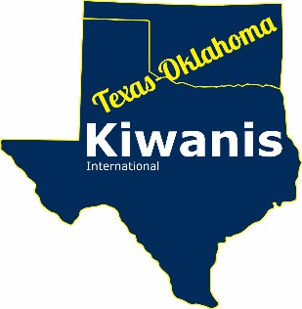

2018 - 2019
Bulletin / Newsletter Contest

Read All About It !!
Deadline for entries:
June 15th, 2019
Does your club produce a newsletter or bulletin? If not, why not? Whether you publish a one page synopsis of the last meeting or a six page production of all events over the last quarter, a printed bulletin or newsletter keeps your members informed and helps to promote your Kiwanis club and all you do. No matter if you
simply hand out copies of your latest publication at a meeting, post it on the internet, or mail to current members, past members or community sponsors, your publication helps to get the word out that Kiwanians are making a difference in communities all over Texas, Oklahoma and the world.

If your club has a newsletter GREAT! Read on about our contest!
If your club does not produce a newsletter - START ONE and read on about our contest!

If you need assistance on preparation of a newsletter, most word processing type programs offer suggestions regarding layout and formatting. You are also welcome to contact the District Office if you have any questions. Send an email to txokdist@swbell.net.

Not a Professional?
You don’t have to have experience or have the latest equipment to get this job done. If you have a typewriter (oh yeah) you can still make your club shine. Black and white, or color….the news is the news. Professionally printed or Xerox copies, it’s the content that matters to both your readers and the judges of this contest. Everyone is on a level playing field. Overall attractiveness counts but content is the key. Please print three of your 2018-2019 newsletter issues and enter the contest. You won’t be sorry and you may be pleasantly surprised!

PAGE 2 BULLETIN / NEWSLETTER CONTEST

Judging Criteria for Entries
Do you produce a bulletin or do you produce a newsletter? Symantec's...we will throw them all in the same hopper for this contest, then separate the publications into categories based on the size of your club. Once again, it’s not the volume, it’s the quality of the content. Some clubs put out a one page bulletin each week and others put out a six page newsletter bi-monthly, which is why we are asking for 3 different issues of your publication.
Points will be awarded for inclusion of the following items:

Awards

Awards
Awards will be presented to 1st and 2nd place in each Club category and in the Division category.

Winners will be announced at the Texas-Oklahoma District Convention in August 2019 and in Ki-Notes!
- Membership information
- Contact Information
- Meeting times and places
- Use of pertinent club information
- Information about the club in the community
- Division, District and Kiwanis Int’l updates
- An invitation for visitors to join you at a meeting
- Use of Kiwanis logos
- Information about SLP programs

Division newsletters/ bulletins will be judged separately from clubs
Club Categories
White: 35 members or less Blue: 36 - 64 members Gold: 65 or more members

Mail or email three different issues of your club’s 2018-2019 publication by June 15, 2019 to:
TX-OK District Office, 3010 W Park Row Dr #100, Pantego, TX 76013 or to txokdist@swbell.net. Be sure to include the category your club fits. Direct questions to Laura Arnhart at the email address above.

