In support of the Corporate Membership Program
Using the new Member, Partner, and Sponsor decals to display at participating businesses

Some clubs in our district thrive on Corporate Memberships to fill their club membership roster. Clubs like the Brownwood Kiwanis Club in north central Texas have gotten more than 10 New Corporate Members since January 1, 2021.
What is a Corporate Member? A corporate membership allows your club to add a local company, business, or non-profit as a supporter of your club. Next to the member’s name you simply check corporate member. Their company or organization, rather than the individual, pays the new member fees and, potentially, the monthly dues.
The company names an employee to attend your meetings. This employee is member of your club just like any other member. They even can hold office and vote! Should that individual leave the company they are always welcome to join your club however, the corporate membership is transferred at no cost to another employee by your club secretary.
While other employees are welcome to assist at fundraisers and service projects only one membership per paid corporate member.
Companies that want to be good corporate citizens find this membership appealing because they recognize the value of affiliation with a well-respected service organization like Kiwanis. An added plus: The corporate member represents company interests within the club and develops a relationship between the company, Kiwanis and other community groups. An excellent example is that non-profit that wishes to use Kiwanis family members as volunteers. Having a seat at the table in your Kiwanis meetings helps to ensure their needs are known.
The Texas Oklahoma Marketing Team has created a series of large (4 inch) decals with either “Member”, “Sponsor”, or “Partner” printed under the Kiwanis K emblem.
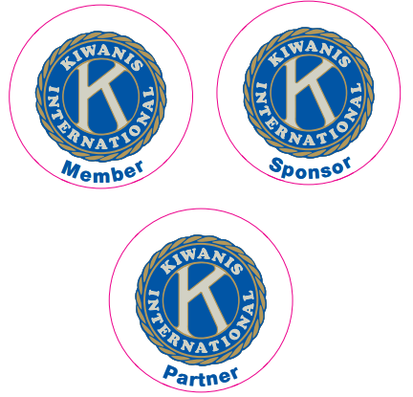
The Member decal could be given to any regular or corporate member that has a business or store front or a glass window to display the decal. If you have a club partner, or someone who trades services with the club but is not actually a member, then the Partner decal would be right for them. If you have an organization or individual that donates funds to the club but can’t arrange a personal membership, then perhaps the Sponsor decal would be great for them to have.
The decals peel off the paper and the sticky side is on the FRONT of the decal so it will be applied on the inside of the glass door or window rather than the outside. It could be applied to the inside of a back window of a car or truck but it is a bit large at 4” across.
Now, the district has arranged to send out a package of 6 decals (2 of each type), membership forms, corporate membership brochures, training brochures, and a small booklet on Engaging Potential Members to clubs in the district. This envelope of goodies is FREE to each club in the district simply by requesting it via an email to Marshall Kregel, Marketing Director, at mkregel@hotmail.com. Send your mailing address in the email! I may not have it in my directory. If you want additional decals, they come in groups of 6 for 5.00/group and you can pick and choose which decals you want. You can send a check to the Texas Oklahoma District, 3010 W. Park Row Dr, Suite 100 Pantego, TX. 76013, and just put “decals” in the note line on the check. The address will also be the return address on the envelope that you get with the order.
If you have questions or need assistance, you can contact either Marshall Kregel, Marketing, at mkregel@hotmail.com or Susan Hennum, Membership, at Susan.Hennum@hotmail.com.
We ordered 1500 of these decals and they are getting popular quickly!! Let’s put one of these on every business window in every town in the district. Each club is entitled to a free packet of decals (6) up front. The funds come from the Marketing account. Additional decals are 5.00 dollars for 6 more decals. 10 dollars for 12 more decals, etc. I’ll use the extra funds to purchase more decals. I have a feeling these are going to be handed out like crazy for a while.
Best regards,
Marshall Kregel
Marketing Director
4/4/2021

