Lieutenant Governor District Dashboard Overview and Guide

Contents:

Duties of the Lieutenant Governor
Tools You Need to Succeed
Login and Set Password
Overview of District Dashboard
Club Elections
Annual Membership Totals
Monthly Report Status
Monthly Report Services
(Currently displays only historical information through 2014-2015)
Monthly Report Key Word Search
InterClub Activity Report
Member Search
Club Meeting Locations

Duties of the Lieutenant Governor

Just as the club president is the leader of the club, the lieutenant governor is the leader of the division.

The lieutenant governor invests effort in working with existing clubs and opening new clubs to strengthen Kiwanis within the communities in the division. This position is the connection between the clubs and the global Kiwanis organization when it comes to communication, resources, education opportunities and information.

The lieutenant governor works closely with club leadership, specifically club presidents, to ensure that they feel supported and have access to information to continuously improve their members’ experience.

The duties of a lieutenant governor include:

- Developing a division action plan, which includes a division membership plan
- Serving as leader for the division membership team
- Remaining accountable for meeting the membership goals for the division

Most lieutenant governor duties support the four roles of the district:

- Supporting and strengthening existing clubs
- Opening new clubs
- Delivering Kiwanis education to clubs, in coordination with Kiwanis International
- Delivering Service Leadership Programs and Global Campaign for Children programming to and through clubs

Tools You Need to Succeed

Kiwanis International provides many tools to help the lieutenant governor succeed. The District Dashboard is an online tool providing current information to help assess overall club health.

The District Dashboard compiles information from all reports submitted by club secretaries and provides information about club successes and challenges within your district.

The District Dashboard allows the lieutenant governor to:

- See status of club election submissions and update officers
- View membership and financial information for clubs
- View monthly report submission status for all clubs in your district
- View report status for all 12 months, per club
- View basic service and fundraising project data for select clubs in your district
- Find service projects by selecting areas of service
- View all interclub activity for the district as submitted on the monthly reports
- Search for individual members

Login and Set Password

If your email address has been submitted to Kiwanis International, then you are ready to register your email address as your login username and create a password for your account.

To do this:

1. Go to kiwanis.org/login
2. Click "Set your password here."

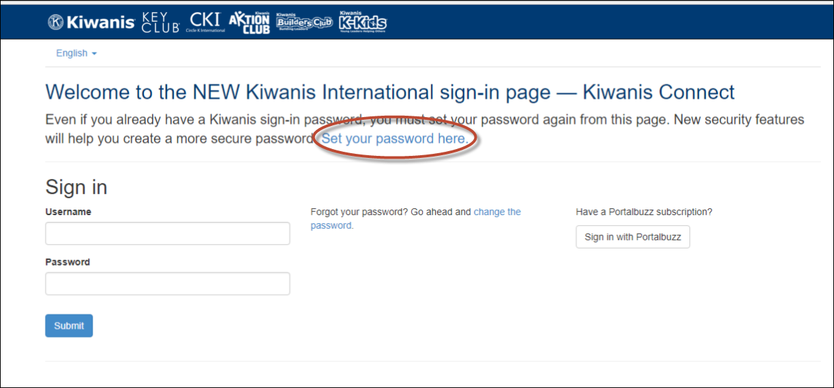

3. Clicking the link will bring you to another page asking for your email address. Enter the email address that was reported to Kiwanis International. An email will be sent to that email address with further instructions to complete the registration process.

Overview of District Dashboard

When you log in, you will have the option to select your club or your division. Be sure to select your division when completing your login.

After you are logged in, you will first see the Me page, showing your name at the top of the page. You also should see the District Dashboard icon on the left side of page.

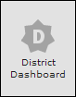

Click this icon, to be taken to the District Dashboard.

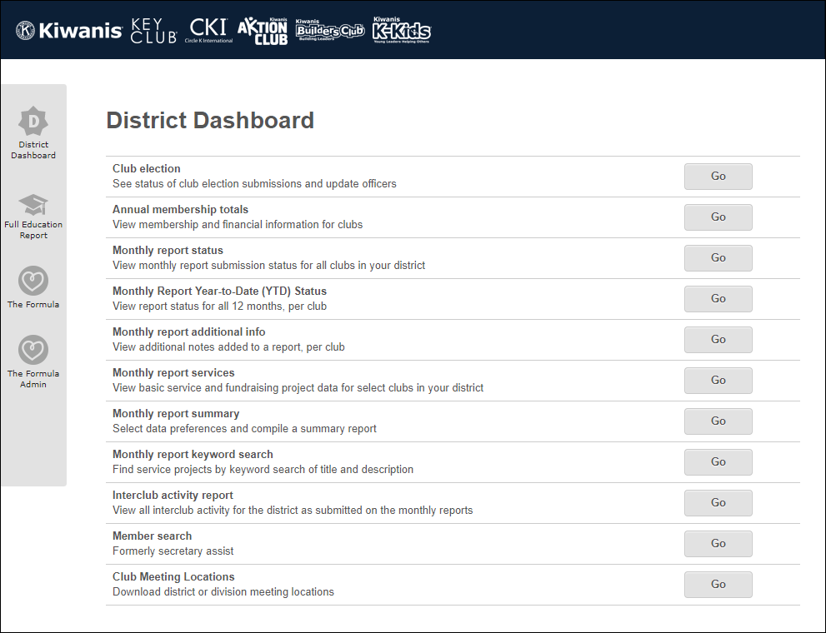

Club Elections

Clicking the Club elections Go button will take you to the Club Election Report page.
See which clubs have submitted their latest election results.
Click the Election Year box to select the year you wish to view.
Quick view features: number of clubs which have reported (circled in red below), green dots indicate officers have been reported.

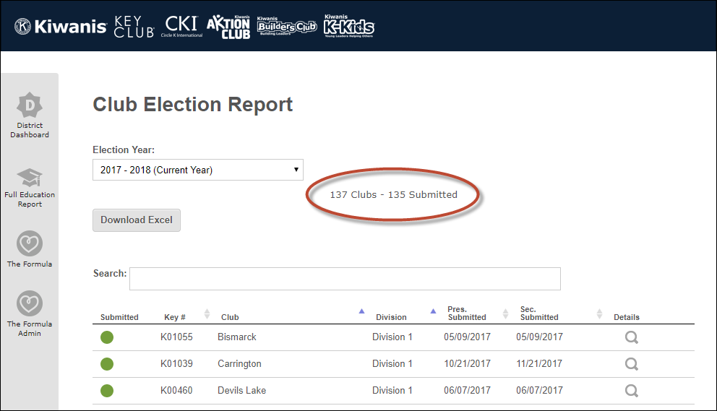

Click the magnifying glass to see officers elected and their contact information.

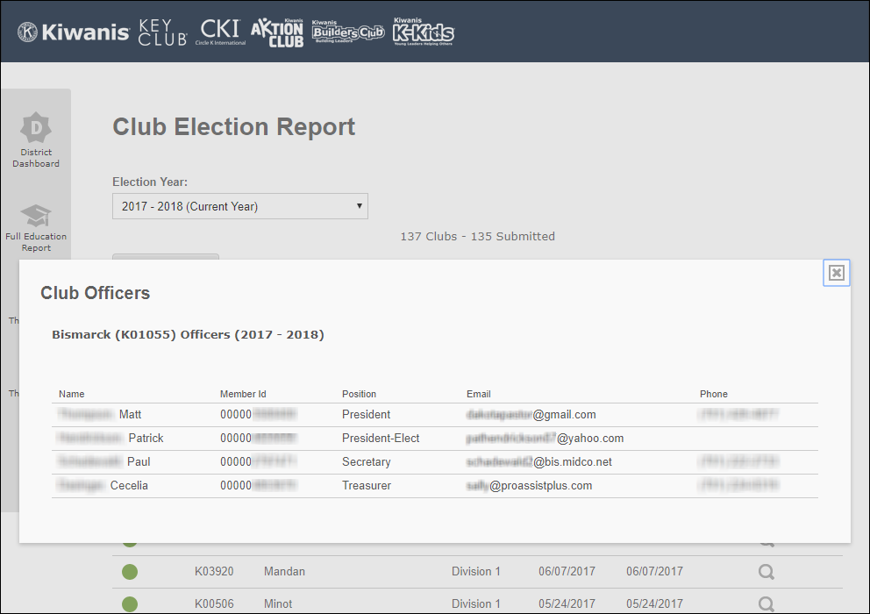

Annual Membership Totals

- See club membership totals and money owed
- View data for any district. Click Update after selecting another district.
- Sort columns by clicking the small arrow next to column header
- A wide range of data comparisons is possible (for example, members at year start and year end for each club)
- Reports may be exported to Excel

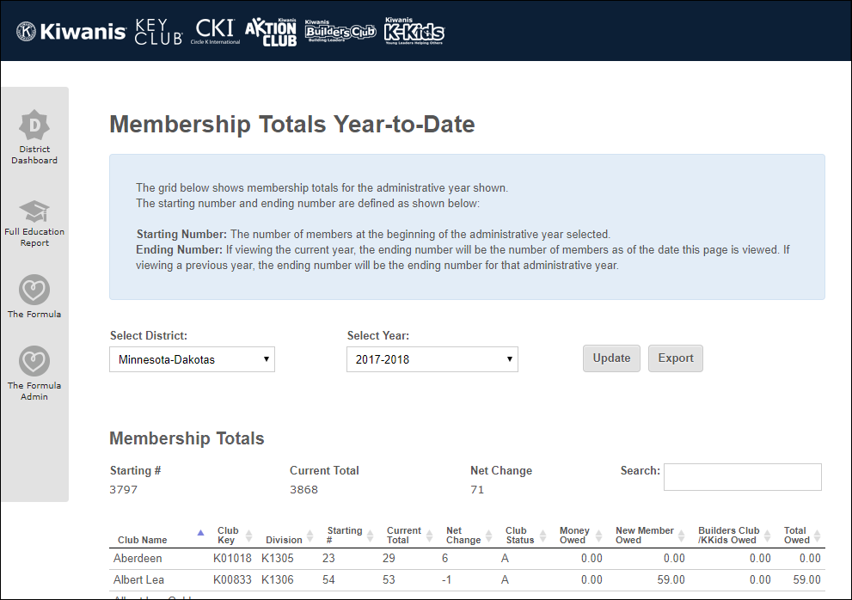

Monthly Report Status
Click the Monthly report status Go button to see a complete history of monthly report submissions for each club.

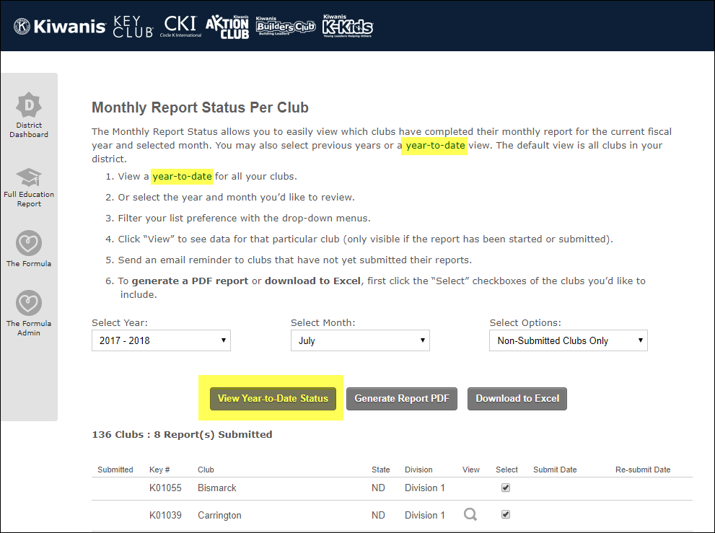

Click a year-to-date status link (highlighted above) to see monthly report submissions grouped by division.

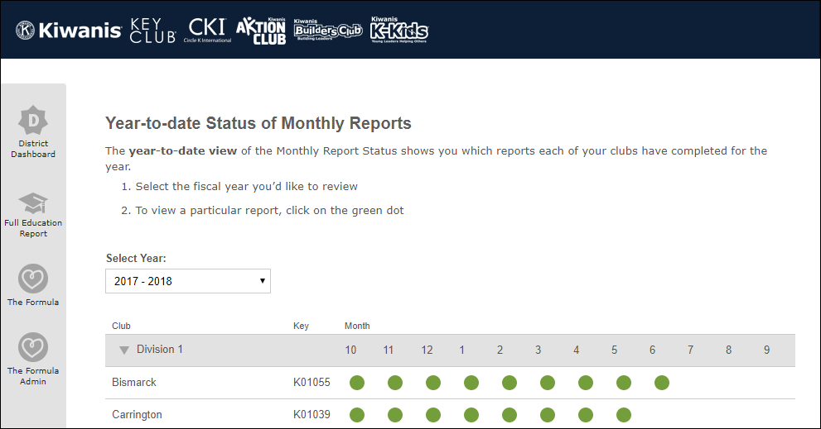

A green dot indicates the report was submitted.
Click a green dot to see the report.

Monthly Report Services

(Currently displays only historical information through 2014-2015)

Click the Monthly Report Services Go button to see Services & Fundraising Projects.
By default, this page lists all service and fundraising projects, by division, beginning with the most recent months reported.

Controls at the top of the page allow you to select and view types of projects.

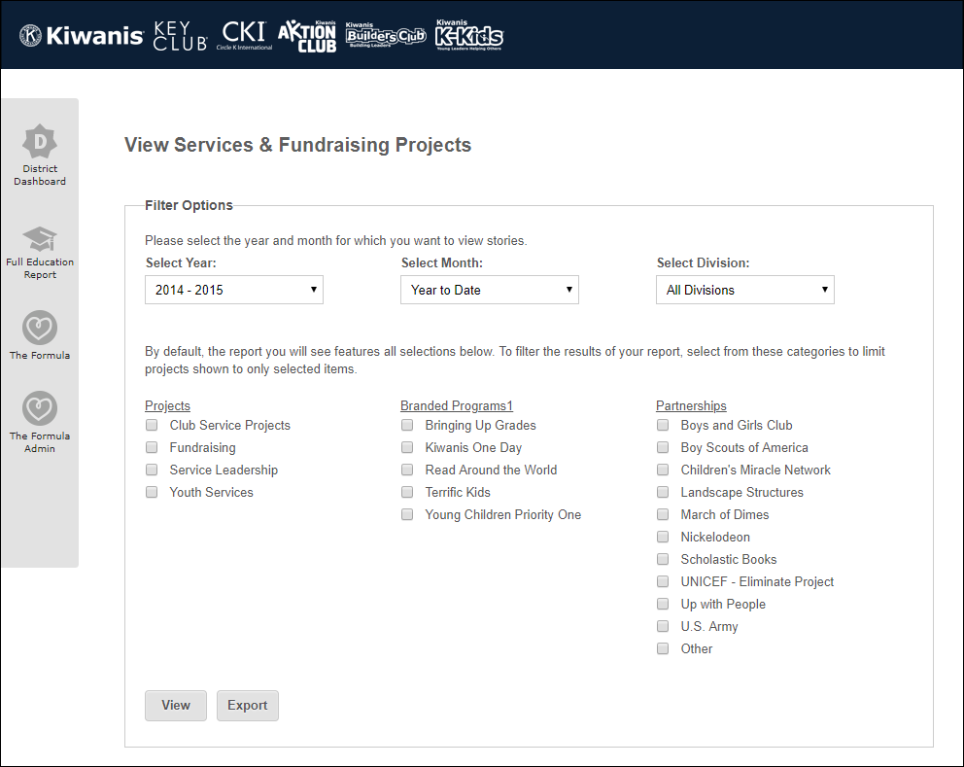

Click the magnifying glass icon to the right of a project to display details.

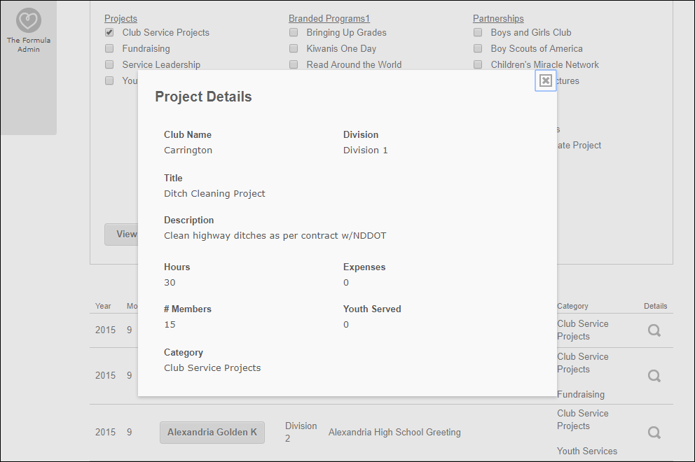

Monthly Report Key Word Search

- Filter results of monthly reports with a keyword search.
(Currently, only historical data is available through 2014-15)
- Select the fiscal year and district to search.
- Enter one or more search keywords in the text box below.
- Click the search button to display results.

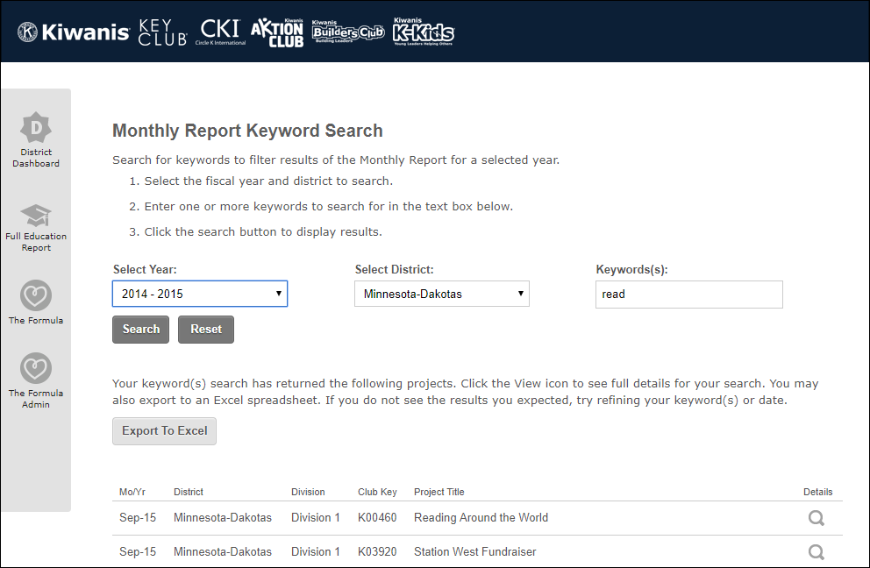

InterClub Activity Report
- See, per division and club name, total visits, members involved, distance travelled, visits per home division and number of sponsored clubs involved.
- Totals displayed as monthly or year-to-date.

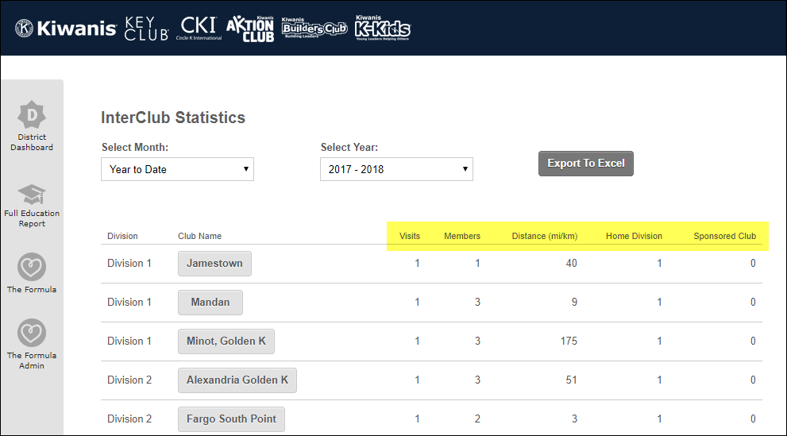

Click the club name visited to see details.

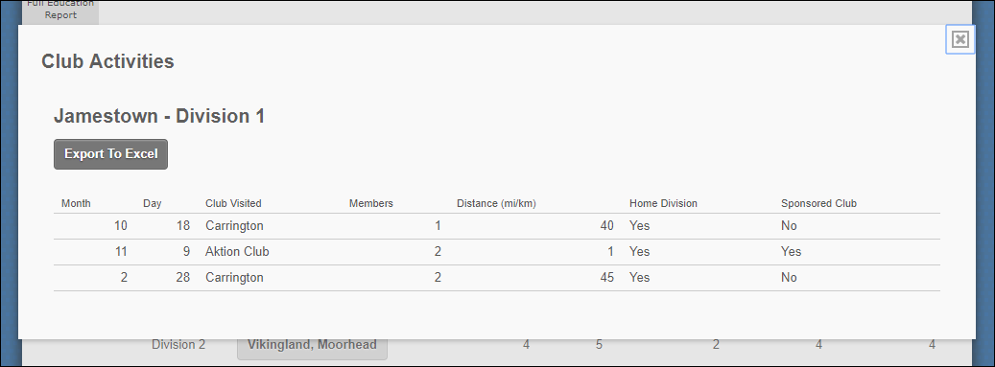
Details may be exported to Excel.

Member Search
- Search for individual members within the district.
- One or more search options may be used.

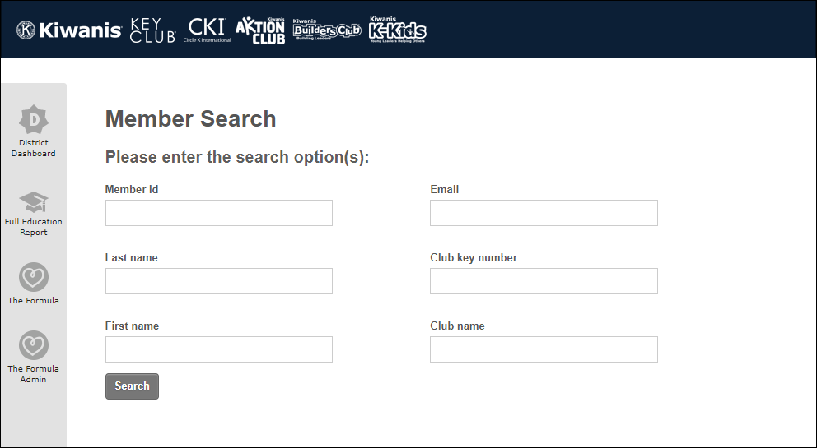

Club Meeting Locations
- Select any district or division (default view is your district)
- Click Download Excel to view data
- Details include meeting address and times, along with contact information.

